CS385 – CPU Project

Robert Rotaru, Bryan Bigelow, Anthony Cerritelli

# Progress Report 2

## Task Format

**Task**

* Subtask – [Contributor 1], [Contributor 2], etc.

## Tasks

**16-Bit Extended Test Program**

* Assembly – Bryan
* Binary – Bryan

**Branching Logic**

* Bne/beq Instructions – Bryan, Rob, Tony
* Branching Modules – Rob, Tony

**Data Memory**

* Memory modules – Rob, Tony
* Sw/lw instructions – Bryan, Rob, Tony

**Diagrams**

* Single-Cycle Path – Tony
* Internals - Bryan

**Report** - Robert Rotaru, Bryan Bigelow, Anthony Cerritelli

## Diagrams

**Single-Cycle Datapath**

**Internals**

Transcoding ALU table into internal signals

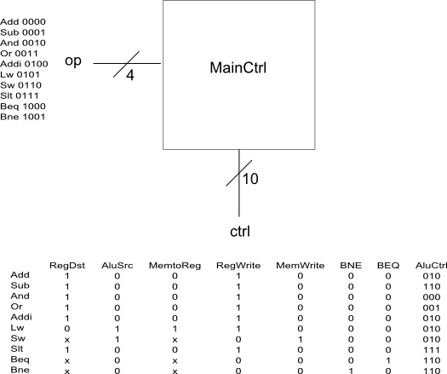

Determining Write Data

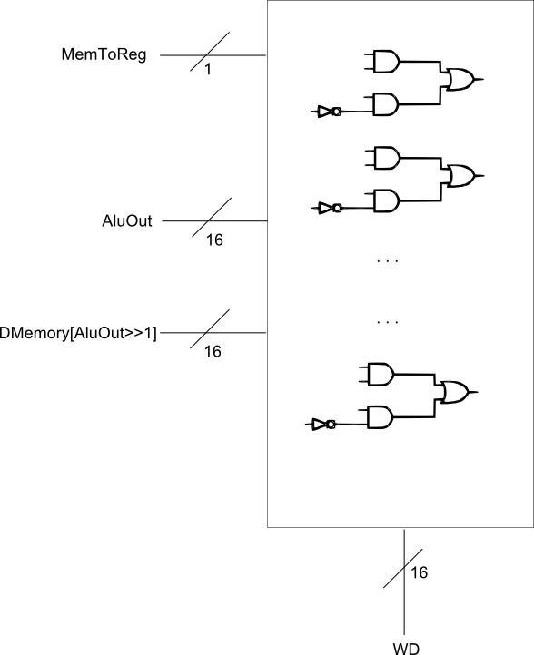

## Source Code

## Testing